Business Question and Visualization Report

Date | 04 October 2025
Team ID | PNT2022TMIDxxxxxx
Project Name | Global Malnutrition Trends: A Power BI Analysis (1983-2019)
Maximum Marks | 5 Marks

Visualization development refers to the process of creating graphical representations of data to facilitate understanding, analysis, and decision-making. The goal is to transform complex datasets into visual formats that are easy to interpret, enabling users to gain insights and make informed decisions. Visualization development involves selecting appropriate visual elements, designing layouts, and using interactive features to enhance the user experience. This process is commonly associated with data visualization tools and platforms, and it plays a crucial role in business intelligence, analytics, and reporting
Business Questions and Visualisation
The process involves defining specific business questions to guide the creation of meaningful and actionable visualizations in Power BI. Well-framed questions help in identifying key metrics, selecting relevant data, and building visualisation that provide insights.

1. What is the total under-five population represented in the dataset?
Visualization: Card/Metric visualization showing total count.
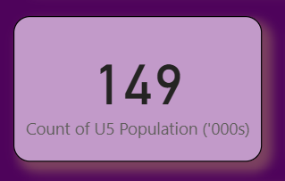

2. How many survey samples were collected overall, and what does this indicate about data robustness?
Visualization: Card/Metric visualization showing total survey sample.
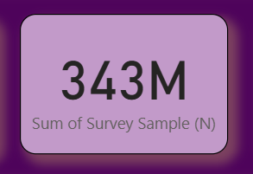

3. What is the global trend of underweight cases among children under five over the years?
Visualization: Line chart showing underweight cases (y-axis) across years (x-axis).
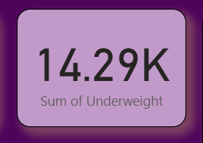

4. How does stunting vary across income classifications (Low, Lower-Middle, Upper-Middle, High Income)?
Visualization: Column chart or clustered bar chart comparing average stunting across income groups.
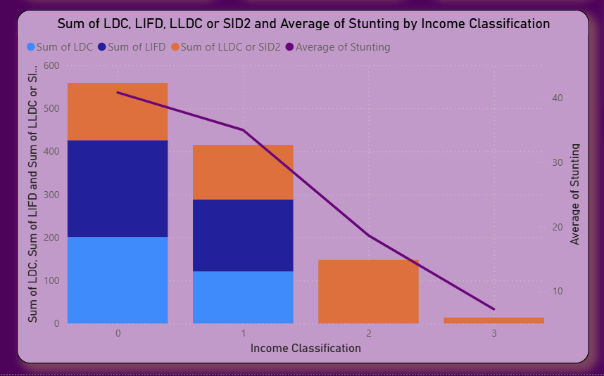

5. Which countries have the highest prevalence of overweight children under five?
Visualization: Horizontal bar chart ranking countries by overweight cases.
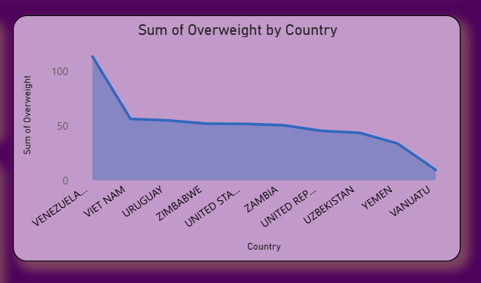

6. How do overweight and underweight trends differ across income levels?
Visualization: Ribbon chart comparing overweight vs. underweight across income groups.
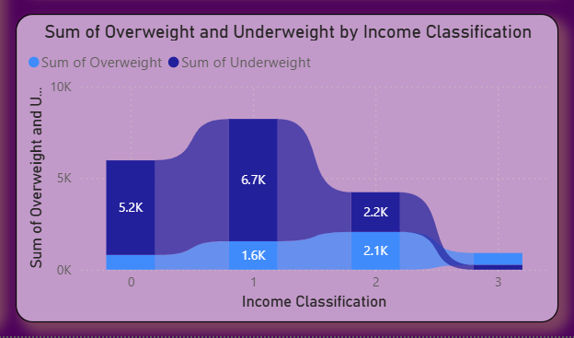

7. Which country categories (LDC, LIFD, LLDC, SIDS) show the highest average stunting levels?
Visualization: Stacked bar chart comparing stunting averages across these categories.
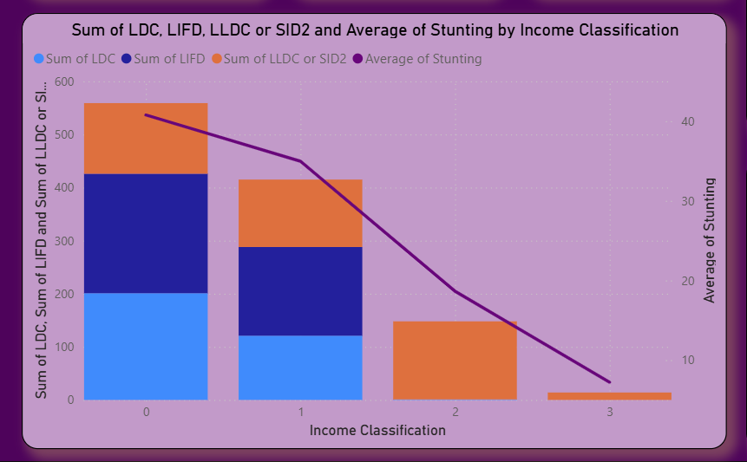

8. What is the Sum of Income Classification globally between 1983 and 2019?
Visualization: Card showing trends of the three indicators across time.
